**10 PhD positions in the Europe Horizon Marie Skłodowska-Curie Project REBONE**

Applications are invited for 10 PhD positions (“Doctoral Researchers”) to be funded by the Marie-Skłodowska-Curie Doctoral Network “REBONE – End-to-end multidisciplinary optimal design for improved personalized bioactive glass/ceramic bone substitute implants”.

The consortium groups nine leading recruiting beneficiaries, as follows.

**Beneficiaries**:

* 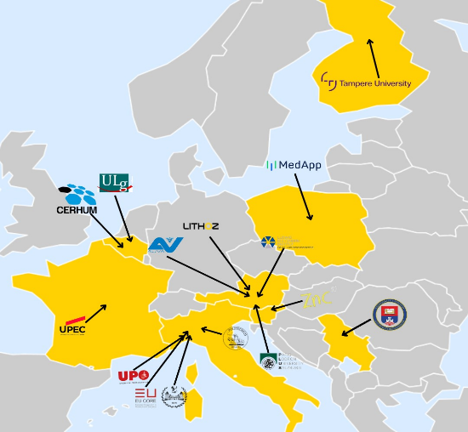**Politecnico di Milano** (POLIMI), Italy – 2 positions
* **Politecnico di Torino** (POLITO), Italy – 1 position
* **Università del Piemonte Orientale** (UPO), Italy – 1 position
* **University of Liegi** (ULG), Belgium –1 position
* **Lithoz GmbH** (LTZ), Austria – 1 position
* **Ludwig Boltzmann Institute** (LBI), Austria – 1 position
* **University of Salzburg** (PLUS), Austria – 1 position
* **University of Belgrade** (UOB), Faculty of Technology and Metallurgy, Republic of Serbia – 1 position
* **MEDAPP SPÓŁKA AKCYJNA** (MEDAPP), Poland – 1 position

**This outstanding group of recruiting institutions is complemented by six outstanding Associated Partners, which are leaders in their field of action**

* **EU CORE Consulting** (EUCORE), Italy
* **CERHUM**, Belgium
* **Science on the Street**, Institute for the Promotion of Science (SoS), Slovenia
* **Tampere University** (TAU), Finland
* **University of Paris Est Créteil** (UPEC), France
* **AUVA Trauma Centre** (AUVA), Austria

**REBONE project – Scientific domains and key project information**

REBONE is a four-year Doctoral Network, funded by the Europe Horizon Marie Skłodowska programme, aiming at innovatively training a new generation of researchers to develop a multidisciplinary optimization process aimed at providing technologies for personalized bone-substitute implants, based on bioactive ceramics to address the health and societal burdens of trauma and bone diseases.

The musculoskeletal system is extremely vulnerable to ageing and traumatic events, and common clinical conditions often impose a high burden on the clinical system. For patients requiring bone-substitute implants to treat critical-size bone defects, new solutions are needed to address important unmet needs: personalised solutions for better clinical outcomes; improvements in materials to ensure higher mechanical reliability without compromising bioactive and bioresorbable properties; optimised manufacturing technologies for materials and products of high reliability and quality.

In order to achieve these ambitious goals REBONE is about to open 10 fully funded PhD positions to construct a platform of computational tools that will enable clinical experts to produce customized bone graft substitutes for the treatment of critical-size bone defects. This innovation will ensure that an ideal treatment solution is found on a patient-specific basis in terms of:

* mechanical and mechano-biological performance,
* surgical implantability, and
* manufacturing process reliability.

Furthermore, REBONE will develop state-of-the-art in silico models based on advanced computational methods and advanced characterisation and validation techniques to obtain personalised implants with a surgical planning visualization system in mixed reality with the following characteristics:

* tailored and reliable mechanical and physical properties;
* best osteointegration capability;
* targeted mechanical, physical and mechano-biological functions with patient-specific constraints taking into account the load-bearing anatomical location. Four selected clinical cases will be used as demonstrators of the optimization design and manufacturing processes.

**LIST OF AVAILABLE PhD POSITIONS**

Complete list of the 10 Doctoral positions available within REBONE:

1. Position 1: *Methods for optimization of bone-substitute architectures* (*Politecnico di Milano, Italy*);
2. Position 2: *Micro- and macro-mechanical characterization of materials and devices and in-silico Models* (*Politecnico di Milano, Italy*);
3. Position 3: *3D printing technologies for Glass-Ceramic and Glass-Ceramic-based composite BTE scaffolds* (*Politecnico di Torino, Italy*);
4. Position 4: *Tissue-scaffold biological interaction* (*Università del Piemonte Orientale, Italy*)
5. Position 5: *Design of bone inspired scaffolds and biomechanical characterization of the bone-scaffold construct (Université de Liege, Belgium)*
6. Position 6: *Industrial process for glass-ceramic device manufacturing through VPP (Lithoz GmbH, Austria)*
7. Position 7: *Characterization of fracture relevant bone sites for information on the structural/compositional requirements of the implant (Ludwig Boltzmann Institute, Austria)*
8. Position 8: *Models for Tissue growth and fundamental relationships with micro-architecture of scaffolds* (*University of Salzburg, Austria*)
9. Position 9: Biomimetic in vitro culture models for evaluation of novel bone substitute implants (*University of Belgrade, RS*)
10. Position 10: *Mixed reality for planning of implant surgery for bone defects of irregular shapes (MEDAPP SPÓŁKA AKCYJNA, Poland)*

**OVERALL ELIGIBILITY CRITERIA**

All applicants need to fully respect the following MSCA eligibility criteria:

1. They must be doctoral candidates, i.e. not already in possession of a doctoral degree at the date of the recruitment.
2. They can be of any nationality **BUT** must comply with the following mobility rule: they must not have resided or carried out their main activity (work, studies, etc.) in the country of the recruiting beneficiary for more than 12 months in the 36 months immediately before their recruitment date.
3. They have to comply with the required profile described at the level of each individual position

Additional eligibility criteria are specified at the level of the description of each PhD positions in what follows.

**RECRUITMENT PROCESS KEY DATES**

* **Beginning of January 2024:** launching of the 10 PhD positions on the REBONE website (to be opened on the project website https://rebone.eu/). The webpage will contain precise information on the selection procedure as well as on the documents to be prepared;
* **01/03/2024**: deadline for on-line applications;
* **02/03/2024**- **30/05/2024**: selection procedures and interviews;
* **Tentatively by 01/06/2024**: conclusion of the recruitment process;
* **01/07/2024**: envisaged start date for the REBONE employment contracts for the selected fellows.

**For info and application procedure please visit the project website** [**https://rebone.eu/**](https://rebone.eu/)